4/28/2017 testing feedback: Same errors.
This is in STAGE NAME Austin OE 2017: TEST CASE Michael Adams EE ID 73172, QE name “Marriage-Add Dependent(s) to coverage.
I get the same error messages as I did in February 2017.
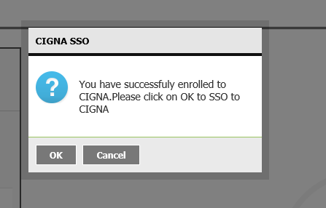

Clicked OK and received the following ERROR.

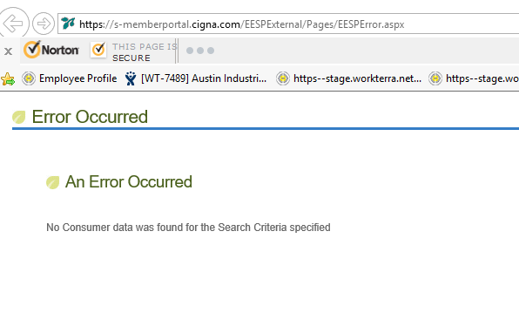

Austin Industries client feedback: Per the BOX below. THE employee will NOT know the answer to this question. Austin Industries employees will have no knowledge if the next benefits require EOI or not. So client stated employees won’t know how to answer it. If they guess then they could either go to EOI too early or they could keep hitting cancel and miss the EOI SSO entirely. If employees choose cancel each time will the EOI SSO box display at the end forcing employees to go to the SSO? The TUNNEL view NEVER showed these boxes it was only when I was signed in as ADMIN enrolling the EE.

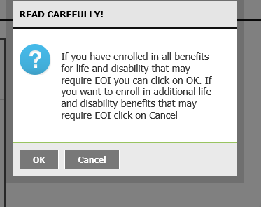

We have an issue for the Voluntary Dependent life. For test case Michael Adams, I get stuck at Voluntary Dependent life.

I get stuck here, there is no choice to select under Voluntary Dependent Life. It has select coverage but there are no choices to choose. So I’m forced to enroll, which I can’t or forced to waive. Issue. 